Lab 8 – LED Flashing

Matthew Romleski  
Jayson Treml

For this lab the goal was to cause an LED to blink every 500ms on an infinite loop on the XMEGA-A1U board provided in-lab.

A simple solution to this is to toggle the port controlling this LED, which is pin 3 on port Q. Then, there needs to be a 500ms delay in-between each toggle in order to have the LED flash at the correct interval.

The code for the pin toggle was written using the lecture slides as a resource, and the delay code was generated via <http://www.bretmulvey.com/avrdelay.html> (slightly tweaking it afterwards to better work with this specific program) with the inputs of a 500ms delay at 2MHz. 2MHz is chosen since it is the default clock speed for the XMEGA-A1U board that was provided. Thus, no additional code is needed to set the clock speed to something specific.

Here is the resulting program, which is fairly similar between the two of us (Jayson had to modify the delay a bit more to get the right numbers): 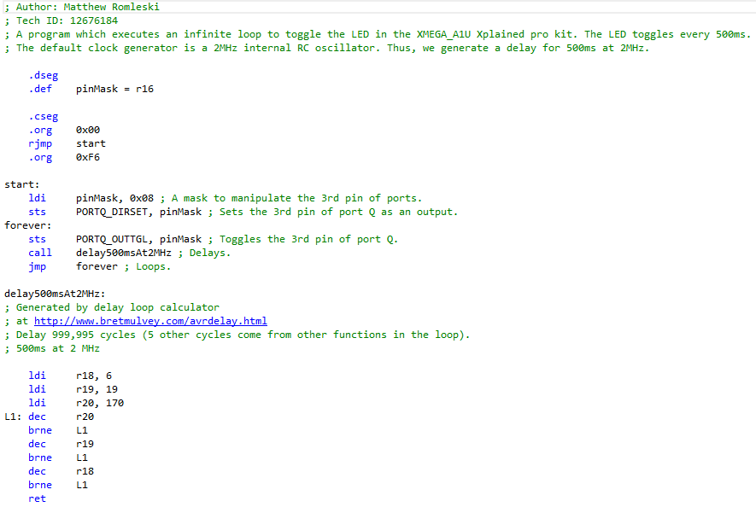

In conclusion, we learned how to utilize the clock speed & respective delay, along with the toggling of pins on the provided microcontroller, to turn on LED on & off every 500ms.